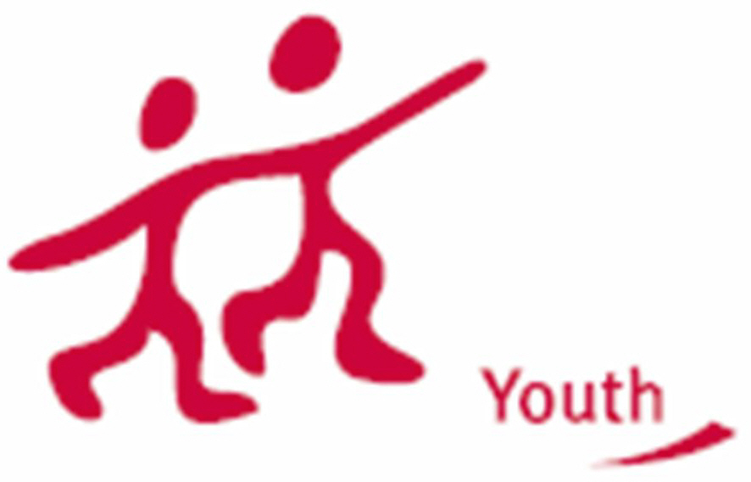
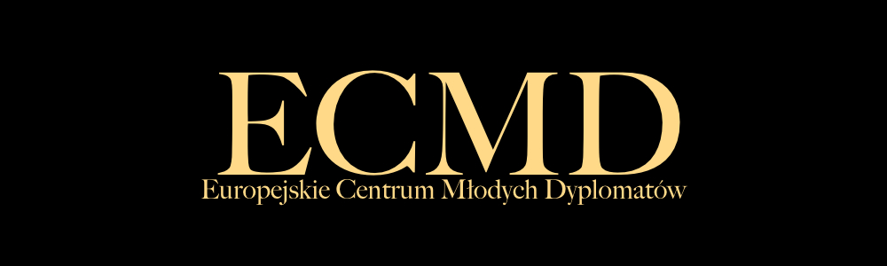

INFORMATION ABOUT THE PROJECT

Partnership Building Activity titled “ONE goal = ONE project”.

It will take place in Zakopane in Poland on 25th – 31st of July 2010.

It will be a meeting of representatives of organizations working in youth fields associated with Millennium Development Goals.
We would like to create a platform of co-operation for partners from many European countries and work together on new projects.
We are looking for experienced participants who know how to organise Youth in Action projects and are motivated to create new project ideas. We are looking for partners who are interested in long-term co-operation in the frame of Youth in Action and new projects realisation.

GOALS:

The mail goals of our PBA activity are following:
1. Preparation of 8 new projects in Youth in Action Programme in the topic of Millennium Development Goals. One project which will be focused on one Goal.
- Goal 1: Eradicate extreme poverty and hunger
- Goal 2: Achieve universal primary education
- Goal 3: Promote gender equality and empower women
- Goal 4: Reduce child mortality
- Goal 5: Improve maternal health
- Goal 6: Combat HIV/AIDS, malaria,and other diseases
- Goal 7: Ensure environmental sustainability
- Goal 8: Develop a global partnership for development
2. Promotion of United Nations’ global activities.
3. Activisation of youth societies in local area.
4. Development of quality of Youth in Action projects.
5. Efficient co-opeartion among youth organisations.
6. To establish and run a cohesive partnership with active involvment of all partners and with common goals to be achieved.

Date: 25th – 31st of July 2010

Duration: 5 working days plus 2 travel days (1 day for arrival and 1 day for departure)

Venue: Małopolska region in Poland, city of Zakopane area.

TARGET GROUP (participants profile):

Youth leaders, project co-ordinators, multipliers, members of the board of organisation.
Age: 21-30 years old.
Fluent in English.
Motivated to achive goals of the project.

Eligible countries: EU countries + Lichtenstein, Norway, Iceland + Turkey

Maximum 2 participants from each country.

COSTS:

Accommodation, food and visa fee (if needed) will be covered in 100 % by organisers.
Travel cost reimbursement will be up to 70%.
Project will be supported by Youth in Action Programme.

CONTACT PERSON:

Claudie-Marie Smolen – President of the Board

Mobile: +48-608528051
Email: claudiemarie.smolen@gmail.com
Fax: 0048-12-662-99-41
Address: ul. Bergela 58; 32-400 Myślenice, Poland.

Basic information about Applicant organisation:

The European Center of Young Diplomats in the period 2006-2009 actively participated in numerous conferences, seminars, cultural events, both in Poland, as well as abroad, mainly in France and Italy. The most important project was prepared in collaboration with the French organization Bourgogne Balkans Express. Its result was the organization of a conference on "Stabilization and Integration Perspectives for the Western Balkans".
ECYD regularly strengthens its position in Poland, through participation in various meetings organized by Polish politicians, diplomats, foreigners and think tanks, such as the Fondation Robert Schuman, the Konrad-Adenauer-Stiftung (KAS), and universities, including the European Academy of Diplomacy as well as the Warsaw School of Economics. The Association was also represented by its board in the European Parliament.

We are waiting for your part III (you can find it in the attachement) to send by fax and postal address till 26th of March 2010.

